**Tutorial 33: Two-way Data Binding – Submitting the form**

In this tutorial we will focus on how to submit the form and how we react to it after the form is submitted. We will also focus on form validation. Ideally when submitting the data, the data would get saved in a database but in the interim, we will be console logging the data.

Make sure **Tutorial 32** is complete to be able to move on to this tutorial or clone the [vue3-firebase-course](https://github.com/younggrasshopperza/vue3-firebase-course) repository and go to branch called **Tutorial-32** and navigate to the web-form folder.

**Step 1:** In the **Signup.vue** file, at the bottom of the form we create a button that submits the form.

Create a div tag with a class called submit. Inside the div create a button tag and inside write the “Create Account”.

Look at the example below (**Between Line 30 and line 32**):

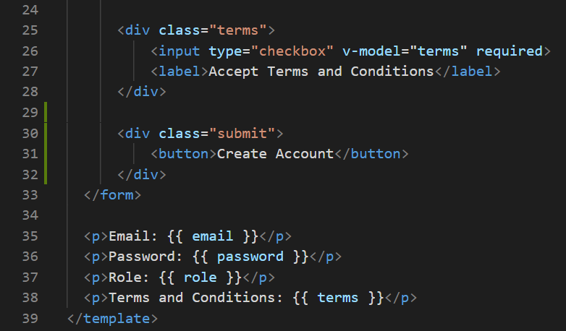

**Step 2:** In the **Signup.vue** file, add the following CSS style:

button {

    background: #0b6dff;

    border: 0;

    padding: 10px 20px;

    margin-top: 20px;

    color: white;

    border-radius: 20px;

    cursor: pointer;

}

button:hover {

    opacity: 0.8;

}

.submit {

    text-align: center;

}

**Output:**

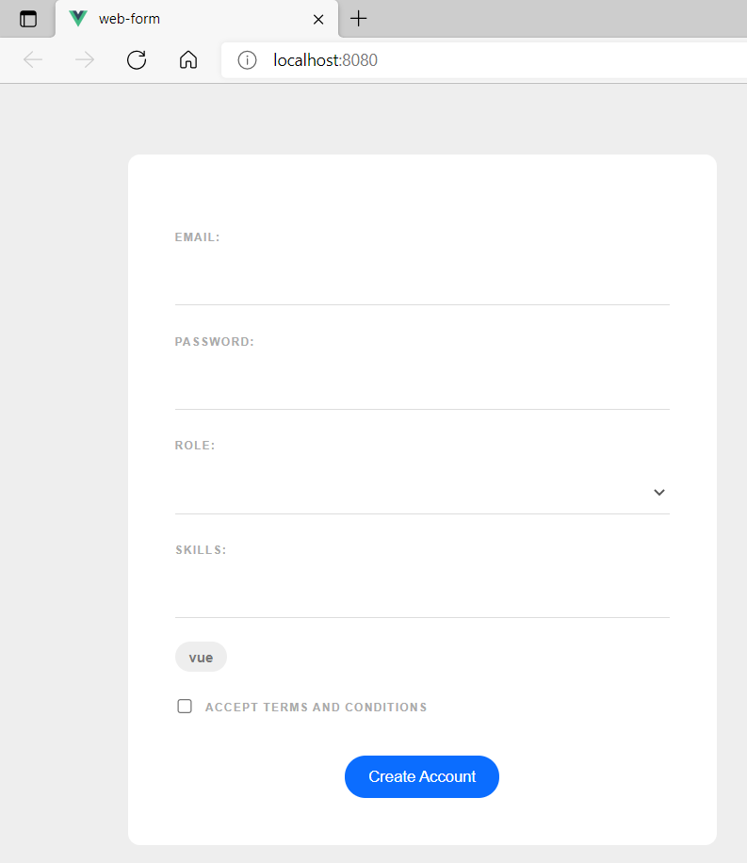

**Step 3:** In the **Signup.vue** file, we will be submitting a submit event to the form. In the form tag attach a submit event that passes a function called handleSubmit.

Look at the example below (**Line 2**):

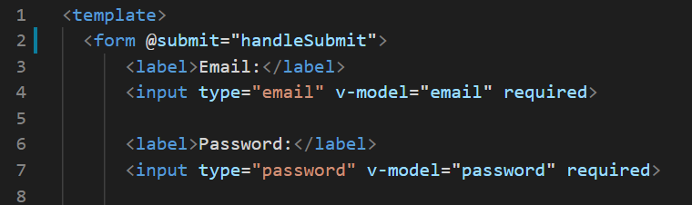

In order to prevent the website from reloading after submitting the form we have to include an event modify called prevent.

Look at the example below (**Line 2**):

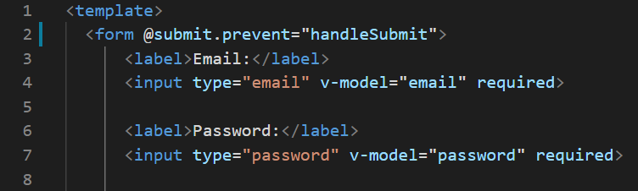

**Step 4:** In the **Signup.vue** file, create a data property called passwordError. Create a method property called handleSubmit. Inside the function we are going to validate the password by checking if the password length is over 5 characters. If the password is over 5 characters, then an error message should be assigned to the passwordError data property.

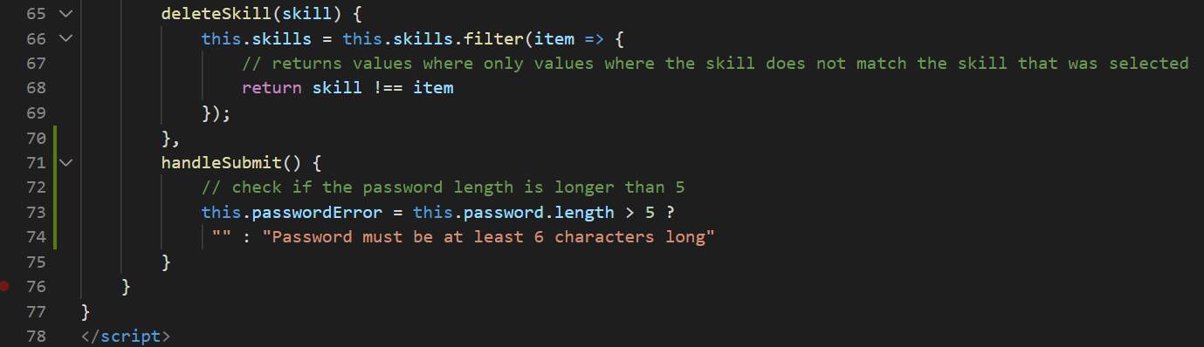Look at the example below (**Between** **line 71 and 75**):

**Step 5:** In the **Signup.vue** file, we will output the error message if the password validation is incorrect. Under the password input field, create a div tag with a class called error, with the v-if attribute that checks whether passwordError data property has a value. Output the passwordError data property when there is an error.

Look at the example below (**Line 8**):

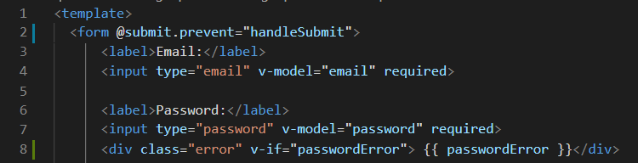

add the following css code:

.error {

    color: #ff0062;

    margin-top: 10px;

    font-size: 0.8em;

    font-weight: bold;

}

**Output:**

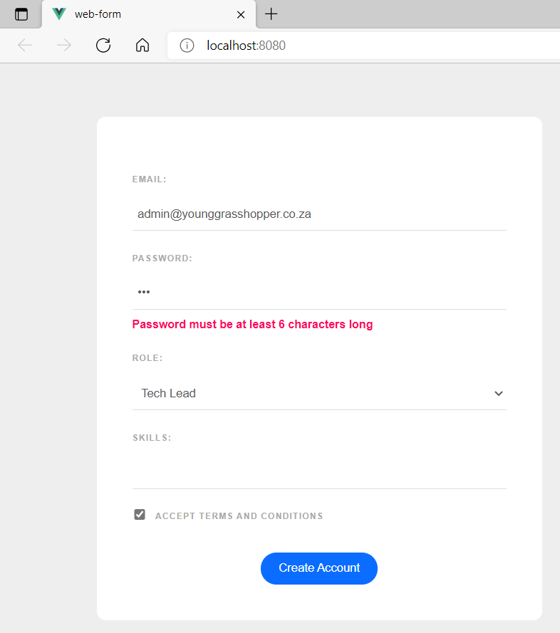

**Step 6:** In the **Signup.vue** file, console log all the value if there is no password error message.

Look at the example below (**Between** **line 77 and 83**):

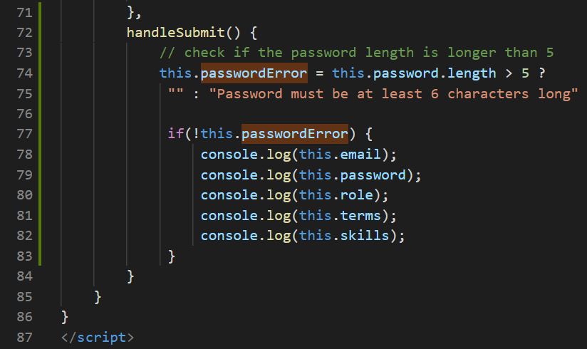

**Output:**

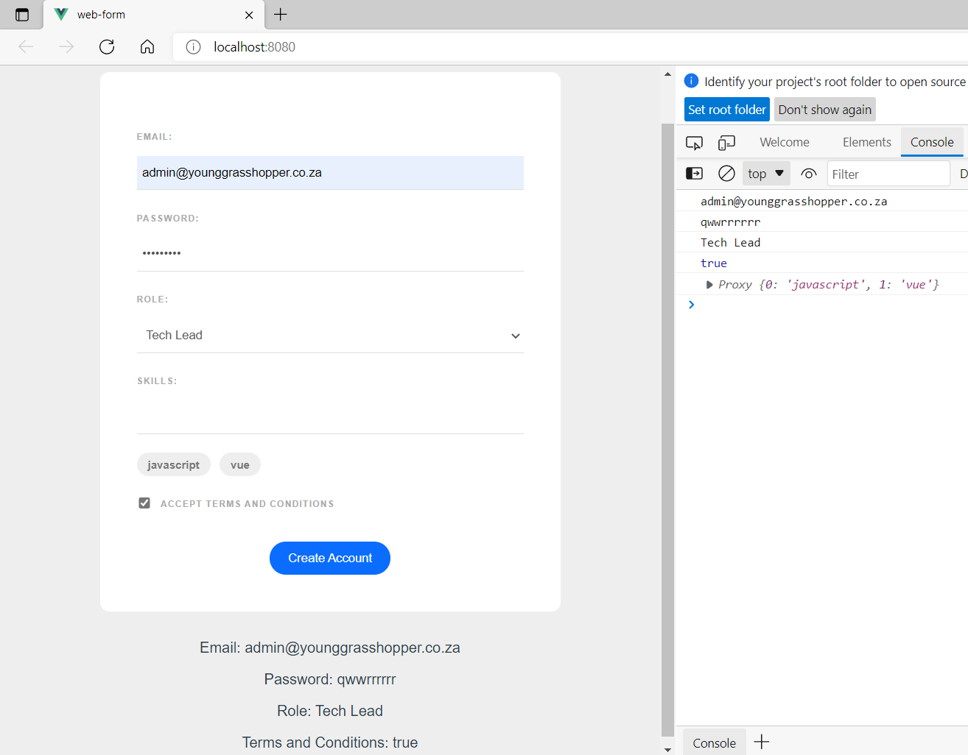

**You can view the code snippets from the** [**vue3-firebase-course**](https://github.com/younggrasshopperza/vue3-firebase-course) **repository under the Tutorial-33 branch**.